Q1.
The equation below shows the process by which two atomic nuclei join to form a different nucleus.
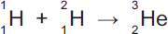
(a) Where does the process shown by the equation above happen naturally?
Tick () one box.

Inside the Earth | 
Inside a nuclear power station
Inside the Sun
(1)
(b) Use the correct answer from the box to complete the sentence.

fission | force | fusion
The process of joining two atomic nuclei to form a different nucleus is called
nuclear _________________________ .
(1)
(c) What is released during this process?
Draw a ring around the correct answer.

charge | energy | force
(1)
(Total 3 marks)
Q2.
Nuclear power can be used to generate electricity through nuclear fission.
Figure 1 shows the process of nuclear fission.
Figure 1
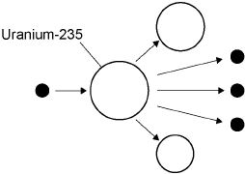
(a) Complete the sentences.
Choose answers from the box.

gamma rays | light rays | proton | neutron | nucleus | X-rays
During the process of nuclear fission, a uranium ___________________
absorbs a ___________________ .
Electromagnetic radiation is released in the form of ___________________ .
(3)
(b) The UK needs at least 25 000 000 kW of electrical power at any time.
A nuclear power station has an electrical power output of 2 400 000 kW
Calculate how many nuclear power stations are needed to provide 25 000 000 kW of electrical power.
___________________________________________________________________
___________________________________________________________________
___________________________________________________________________
___________________________________________________________________
Number of nuclear power stations = _______________________
(2)
(c) State two environmental issues caused by generating electricity using nuclear power stations.
1. _________________________________________________________________
___________________________________________________________________
2. _________________________________________________________________
___________________________________________________________________
(2)
(d) The UK currently generates a lot of electricity by burning natural gas. This process releases carbon dioxide into the atmosphere.
Figure 2 shows how the concentration of carbon dioxide in the atmosphere has changed over the past 115 years.
Figure 2
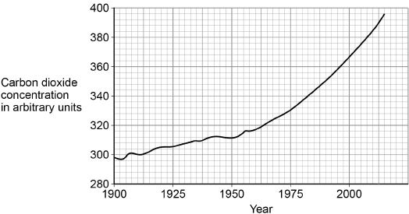
Figure 3 shows how the global temperature has changed over the past 115 years.
Figure 3
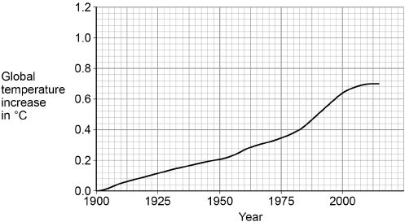
Give one similarity and one difference between the data in Figure 2 and Figure 3.
Similarity ___________________________________________________________
___________________________________________________________________
___________________________________________________________________
Difference __________________________________________________________
___________________________________________________________________
___________________________________________________________________
(2)
(Total 9 marks)
Q3.
Some isotopes emit nuclear radiation.
(a) Carbon-12 and carbon-14 are both isotopes of carbon.
Complete the sentences.
Choose answers from the box.

alpha particles | electrons | neutrons | protons
The nucleus of a carbon-12 atom and the nucleus of a carbon-14 atom have the
same number of _________________________.
The nucleus of a carbon-12 atom and the nucleus of a carbon-14 atom have a
different number of _________________________.
(2)
(b) Different radioactive isotopes have different half-lives.
What does ‘half-life’ mean?
Tick (✓) one box.

Half the time taken for all of the nuclei in a sample to decay. | 
The time taken for half the nuclei in a sample to decay.
The time taken for one nucleus to split in half.
(1)
(c) Table 1 shows the half-life of some different isotopes of carbon.

Table 1
Isotope | Half-life in seconds
Carbon-15 | 2.45
Carbon-16 | 0.75
Carbon-17 | 0.19
Carbon-18 | 0.09
Which isotope is the least stable?
Tick (✓) one box.

Carbon-15
Carbon-16
Carbon-17
Carbon-18
(1)
(d) Workers in nuclear power stations must be aware of nuclear irradiation and radioactive contamination.
Draw one line from each term to an example of the term.

Term |  | Example
 |  | Exposure to a beam of gamma rays
Radioactive contamination
 |  | Exposure to ultraviolet radiation from the Sun
 |  | Accidental transfer of plutonium onto a human body
Nuclear irradiation
 |  | Using a mobile phone
(2)
(e) Why are workers required to walk across a sticky floor before leaving the nuclear power station?
Tick (✓) one box.

To remove alpha particles from their shoes.
To remove gamma radiation from their shoes.
To remove radioactive dust from their shoes.
(1)
(f) The places where people work and live contribute to the nuclear radiation they are exposed to.
Table 2 shows the mean daily dose of radiation caused by two different jobs.
Table 2
Job | Mean daily dose in mSv
Aeroplane pilot | 0.072
Nuclear power station worker | 0.00050
Calculate the number of days a nuclear power station worker must work before receiving the same dose that an aeroplane pilot receives in one day.
___________________________________________________________________
___________________________________________________________________
___________________________________________________________________
Number of days = _______________
(2)
(g) The process of nuclear fission takes place in nuclear power stations.
The process of nuclear fusion takes place in the Sun.
Draw one line from each process to its fuel.

Process |  | Fuel
 |  | Hydrogen
Nuclear fission
 |  | Iron
 |  | Lead
Nuclear fusion
 |  | Uranium
(2)
(Total 11 marks)
Q4.
The process of nuclear fusion results in the release of energy.
(a) (i) Describe the process of nuclear fusion.
______________________________________________________________
______________________________________________________________
______________________________________________________________
______________________________________________________________
(2)
(ii) Where does nuclear fusion happen naturally?
______________________________________________________________
(1)
(b) For many years, scientists have tried to produce a controlled nuclear fusion reaction that lasts long enough to be useful. However, the experimental fusion reactors use more energy than they produce.
(i) From the information given, suggest one reason why nuclear fusion reactors are not used to produce energy in a nuclear power station.
______________________________________________________________
______________________________________________________________
(1)
(ii) Suggest one reason why scientists continue to try to develop a practical nuclear fusion reactor.
______________________________________________________________
______________________________________________________________
(1)
(Total 5 marks)
Q5.
The table gives information about the three types of particle that make up an atom.

Particle | Relative mass | Relative charge
Proton |  | +1
Neutron | 1
Electron | very small | –1
(a) Complete the table by adding the two missing values.
(2)
(b) Use the information in the table to explain why an atom has no overall electrical charge.
___________________________________________________________________
___________________________________________________________________
___________________________________________________________________
___________________________________________________________________
(2)
(c) Uranium has two natural isotopes, uranium-235 and uranium-238.
Uranium-235 is used as a fuel inside a nuclear reactor.
Inside the reactor, atoms of uranium-235 are split and energy is released.
(i) How is the structure of an atom of uranium-235 different from the structure of an atom of uranium-238?
______________________________________________________________
______________________________________________________________
(1)
(ii) The nucleus of a uranium-235 atom must absorb a particle before the atom is able to split.
What type of particle is absorbed?
______________________________________________________________
(1)
(iii) The nucleus of an atom splits into smaller parts in a reactor.
What name is given to this process?
______________________________________________________________
(1)
(Total 7 marks)
Q6.
Nuclear fission and nuclear fusion are two processes that release energy.
(a) (i) Use the correct answer from the box to complete each sentence.

Geiger counter | nuclear reactor | star
Nuclear fission takes place within a ____________________________ .
Nuclear fusion takes place within a _____________________________ .
(2)
(ii) State one way in which the process of nuclear fusion differs from the process of nuclear fission.
______________________________________________________________
______________________________________________________________
(1)
(b) The following nuclear equation represents the fission of uranium-235 (U-235).

Chemical symbols:
Ba - barium
Kr - krypton
(i) Use the information in the equation to describe the process of nuclear fission.
______________________________________________________________
______________________________________________________________
______________________________________________________________
______________________________________________________________
______________________________________________________________
______________________________________________________________
______________________________________________________________
______________________________________________________________
(4)
(ii) An isotope of barium is Ba-139.
Ba-139 decays by beta decay to lanthanum-139 (La-139).
Complete the nuclear equation that represents the decay of Ba-139 to La-139.

(3)
(Total 10 marks)
Q7.
The process of nuclear fission is used in nuclear power stations.
The figure below shows the process of nuclear fission.
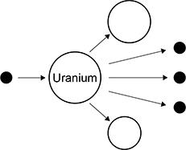
(a) Complete the sentences.
Choose answers from the box.

electrons | gamma rays | neutrons | nuclei | protons

In nuclear power stations, energy is released from uranium
______________________________ .
The uranium in above figure splits into two parts and releases three
______________________________ .
The process of nuclear fission releases electromagnetic radiation in the form of
______________________________.
(3)
Use the Physics Equations Sheet to answer parts (a) and (b).
(b) Write down the equation which links energy (E), power (P) and time (t).
___________________________________________________________________
(1)
(c) A nuclear power station has a power output of 500 MW.
Calculate the energy output in 3600 s.
Give your answer in J.
___________________________________________________________________
___________________________________________________________________
___________________________________________________________________
___________________________________________________________________
___________________________________________________________________
Energy output = ____________________ J
(3)
(d) Radioactive waste produced by nuclear power stations has a long half-life.
Suggest one precaution taken to reduce the hazard caused by radioactive waste from power stations.
___________________________________________________________________
___________________________________________________________________
___________________________________________________________________
(1)
(e) Nuclear power stations do not generate electricity every day of the year.
One nuclear power station generated electricity for 92% of a year.
one year = 365 days
Calculate the number of days during the year that the nuclear power station generated electricity.
___________________________________________________________________
___________________________________________________________________
___________________________________________________________________
Number of days = ____________________
(2)
(Total 10 marks)
Q8.
(a) Nuclear fission is used in nuclear power stations to generate electricity. Nuclear fusion happens naturally in stars.
(i) Explain briefly the difference between nuclear fission and nuclear fusion.
______________________________________________________________
______________________________________________________________
______________________________________________________________
______________________________________________________________
______________________________________________________________
(2)
(ii) What is released during both nuclear fission and nuclear fusion?
______________________________________________________________
(1)
(b) Plutonium-239 is used as a fuel in some nuclear reactors.
(i) Name another substance used as a fuel in some nuclear reactors.
______________________________________________________________
(1)
(ii) There are many isotopes of plutonium.
What do the nuclei of different plutonium isotopes have in common?
______________________________________________________________
(1)
(Total 5 marks)
Q9.
(a) Nuclear power stations use the energy released by nuclear fission to generate electricity.
(i) Explain what is meant by nuclear fission.
______________________________________________________________
______________________________________________________________
______________________________________________________________
(2)
(ii) How does nuclear fission lead to a chain reaction?
You may give your answer as a labelled diagram.

______________________________________________________________
______________________________________________________________
(1)
(b) Although nuclear fuels are relatively cheap the total cost of generating electricity using nuclear fuels is expensive. Why?
___________________________________________________________________
___________________________________________________________________
(1)
(c) The table compares the energy released from 1 kg of coal and 1 kg of uranium.

Coal | 29 MJ | 1 MJ = 1 000 000 joules
Uranium | 580 000 MJ
State one benefit to the environment of using a concentrated fuel like uranium to generate electricity rather than using the energy from coal.
___________________________________________________________________
___________________________________________________________________
(1)
(Total 5 marks)
Q10.
(a) Uranium-234 (²³⁴U) is a radioactive element. The graph shows the number of protons and neutrons in the nuclei of the elements formed when uranium-234 decays.
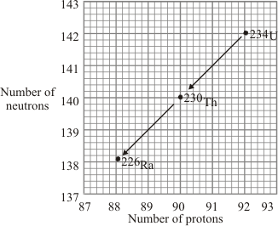
(i) How does the graph show that uranium-234 (²³⁴U) and thorium-230 (²³⁰Th) emit alpha particles?
______________________________________________________________
(1)
(ii) What makes uranium and thorium different elements?
______________________________________________________________
(1)
(iii) Radioactive decay may also produce gamma radiation.
Why does the emission of gamma radiation not cause a new element to be formed?
______________________________________________________________
______________________________________________________________
(1)
(b) The graph shows how the thickness of different materials needed to absorb 90% of the gamma radiation emitted by a source depends on the energy of the radiation. The energy of the gamma radiation is given in units called electron-volts.
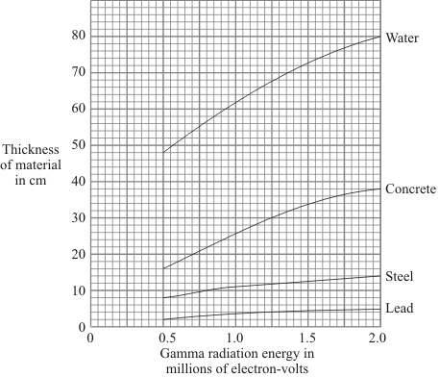
(i) Which of the materials shown is least effective at absorbing gamma radiation?
Use the information in the graph to give a reason for your answer.
______________________________________________________________
______________________________________________________________
(1)
(ii) For gamma radiation of energy 1.5 million electron-volts, how many times more effective is steel than water at absorbing the radiation? Show clearly how you obtain your answer.
______________________________________________________________
______________________________________________________________
______________________________________________________________
(2)
(c) Scientists in the early twentieth century thought that atoms were made up of electrons scattered inside a ball of positive charge. This was called the ‘plum-pudding’ model of the atom.
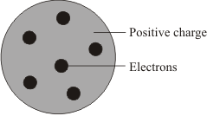
Plum pudding model
Rutherford and Marsden did an experiment, in which a beam of alpha particles was aimed at a thin sheet of gold.
Explain how the results of this experiment led to a new model of the atom.
You may include one or more diagrams in your answer.

___________________________________________________________________
___________________________________________________________________
___________________________________________________________________
___________________________________________________________________
___________________________________________________________________
___________________________________________________________________
(3)
(Total 9 marks)
Q11.
At the very high temperatures in the sun, hydrogen is converted into helium. It takes four hydrogen nuclei to produce one helium nucleus.
The table shows the relative masses of hydrogen and helium nuclei.
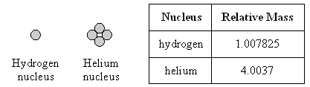
(a) Use these figures to calculate what happens to the mass of the sun as hydrogen is converted to helium.
___________________________________________________________________
___________________________________________________________________
___________________________________________________________________
___________________________________________________________________
(3)
(b) Use your answer to part (a) to explain how the sun has been able to radiate huge amounts of energy for billions of years.
___________________________________________________________________
___________________________________________________________________
___________________________________________________________________
(2)
(Total 5 marks)
Q12.
The first commercial nuclear power station in the world was built at Calder Hall in Cumbria.
The atoms produced by the fission of uranium are also radioactive. The used fuel is sent to a reprocessing plant where it can be safely treated.
(i) Calder Hall power station is next to the Sellafield reprocessing plant. Suggest an advantage of having the two plants close together.
___________________________________________________________________
___________________________________________________________________
(1)
(ii) One of the radioactive products is iodine-138. This has a half-life of 6 seconds.
A sample of radioactive material contains 2000 atoms of iodine-138.
How long will it take for the number of iodine-131 atoms to decrease to 125?
___________________________________________________________________
___________________________________________________________________
___________________________________________________________________
___________________________________________________________________
Answer = _______________ seconds
(3)
(Total 4 marks)

Mark schemes
Q1.
(a) inside the Sun
1
(b) fusion
1
(c) energy
1
[3]
Q2.
(a) nucleus
1
neutron
1
gamma rays
1
in this order only
(b) 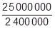
1
11
an answer of 10.4 with no working scores 1 mark
1
an answer of 11 scores 2 marks
(c) any two from:
• waste is radioactive
allow nuclear waste
• waste has a long half-life
allow waste remains dangerous for a long time
• waste is toxic
• waste needs to be buried
allow waste is difficult to dispose of
• risk of catastrophic accidents
allow named accident e.g. Fukushima, Chernobyl, Three Mile Island
• fuel is non-renewable
2
(d) similarity:
(carbon dioxide concentration and global temperature have) both increased
allow they both show a positive correlation
1
difference:
the carbon dioxide (concentration) continues to increase whereas temperature (increase) levels off
allow carbon dioxide (concentration) increases more quickly than temperature (increase)
1
[9]
Q3.
(a) protons
this order only
1
neutrons
1
(b) the time taken for half the nuclei in a sample to decay
1
(c) carbon-18
1
(d)
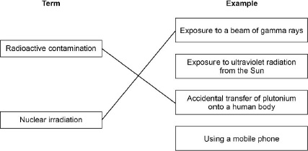
1 mark for each correct line
additional line from a box on the left negates the mark for that box
2
(e) to remove radioactive dust from their shoes
1
(f) 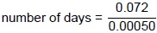
1
number of days = 144
1
(g)
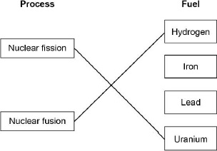
1 mark for each correct line
additional line from a box on the left negates the mark for that box
2
[11]
Q4.
(a) (i) (two) nuclei (of light elements) join
accept hydrogen atoms for nuclei
1
forming a larger / heavier nucleus / one
accept comparative term equivalent to larger
accept forms a helium (nucleus / atom) this mark only scores if fusion is in terms of hydrogen atoms
1
(ii) stars
accept a named star
e.g. the Sun
accept nebula
mention of planets negates answer
1
(b) (i) any one from:
• (currently) only experimental
• reaction does not last long enough
• use more energy than they produce
allow difficult to control
do not allow inefficient on its own
1
(ii) any one from:
• will give another source of energy
• unlimited fuel supplies / energy
accept unlimited hydrogen
• would not produce any radioactive waste
accept less radioactive waste
accept nuclear for radioactive
do not accept toxic waste
• want to show that it can be done
accept any sensible suggestion
do not accept answers only in terms of fossil fuels or carbon dioxide
1
[5]
Q5.
(a)
Particle | Relative Mass | Relative charge
Proton | 1
Neutron |  | 0
accept one, accept +1
do not accept –1
1

accept zero
do not accept no charge/ nothing/neutral unless given with 0
1
(b) equal numbers/amounts of protons and electrons
1
protons and electrons have equal but opposite charge
accept protons charge +1 and electron charge –1
accept (charge) on proton
cancels/balances (charge) on electron
accept positive (charges) cancel out the negative(charges)
neutrons have no charge is neutral
do not accept total charge of protons, electrons (and neutrons) is 0 unless qualified
1
(c) (i) (3) fewer neutrons
accept lower/ smaller mass number
do not accept different numbers of neutrons
any mention of fewer/more protons/electrons negates mark
accept answers in terms of U-238 providing U-238 is specifically stated i.e. U-238 has (3) more neutrons
1
(ii) neutron
1
(iii) (nuclear) fission
accept fision
do not accept any spelling that may be taken as fusion
1
[7]
Q6.
(a) (i) nuclear reactor
1
star
1
(ii) nuclei are joined (not split)
accept converse in reference to nuclear fission
do not accept atoms are joined
1
(b) (i) any four from:
• neutron
• (neutron) absorbed by U (nucleus)
ignore atom
do not accept reacts
do not accept added to
• forms a larger nucleus
• (this larger nucleus is) unstable
• (larger nucleus) splits into two (smaller) nuclei / into Ba and Kr
• releasing three neutrons and energy
accept fast-moving for energy
4
(ii) 56 (Ba)
1
57 (La)
if proton number of Ba is incorrect allow 1 mark if that of La is 1 greater
1
accept e for β
scores 3 marks
1
[10]
Q7.
(a) nuclei
1
neutrons
1
gamma rays
this order only
1
(b) energy = power × time
or
E = P × t
1
(c) P = 500 000 000 (W)
1
E = 500 000 000 × 3600
allow a correct substitution of an incorrectly / not converted value of P
1
E = 1 800 000 000 000 (J)
or
E = 1.8 × 10¹² (J)
allow an answer consistent with an incorrectly / not converted value of P
1
(d) any one from:
• bury the radioactive waste
• put the radioactive waste in cooling ponds
allow store it for (at least) one half-life
• transport the radioactive waste in secure vessels
• store the radioactive waste in metal containers
• cover the radioactive waste in concrete
ignore references to high / medium / low level waste
ignore label the waste as hazardous
1
(e)
number of days = 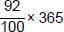
1
number of days = 335.8
allow answers of 335 and 336 days
allow an answer of 29.2 (days) for 1 mark
1
[10]
Q8.
(a) (i) (nuclear) fission is the splitting of a (large atomic) nucleus
do not accept particle/atom for nucleus
1
(nuclear) fusion is the joining of (two atomic) nuclei (to form a larger one)
do not accept particles/atoms for nuclei
1
(ii) energy
accept heat/radiation/nuclear energy
accept gamma (radiation)
do not accept neutrons/neutrinos
1
(b) (i) uranium (–235)
accept U (–235)
ignore any numbers given with uranium
accept thorium
accept MOX (mixed oxide)
do not accept hydrogen
1
(ii) (same) number of protons
accept (same) atomic number
accept (same) positive charge
ignore reference to number of electrons
1
[5]
Q9.
(a) (i) (large) nucleus hit by a neutron
1
splits into (smaller) nuclei and neutron(s) (+ energy)
1
(ii) additional neutrons collide with nuclei causing further fission
allow full credit for a correct labelled diagram
accept 2 or more neutrons given out at each fission reaction
diagram shows 3 discernible sizes, with smaller nuclei and neutrons at same stage
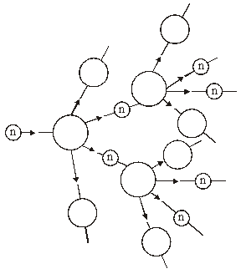
1
(b) cost of (building and) de-commissioning is very high or
cost of building is higher
accept a correct description of de-commissioning
accept high cost to keep the power station safe / secure
accept high cost of reprocessing / storage of nuclear waste
1
(c) less pollution from transport carrying the fuel
accept coal produces more pollutant gases
accept correct named gases
accept more radiation pollution from coal than nuclear
accept more waste from coal than nuclear
do not accept any reference to burning uranium
do not accept answers in terms of global warming or acid rain unless developed
1
[5]

Q10.
(a) (i) both lose 2 protons and (2) neutrons
accept changes by 2 protons and 2 neutrons
1
(ii) different number of protons (in the nucleus)
accept different atomic number
do not accept different number of protons and neutrons or different mass number
ignore electrons
1
(iii) gamma involves no change in the number of protons (in the nucleus)
or gamma is a wave (not a particle)
do not accept number of neutrons
and / or protons
ignore electrons
1
(b) (i) water because
both material and reason required
for all energy values the thickness
of water needed to absorb (90% of)
the radiation is more than the other materials
accept thickness of water required is always more
than the other materials
1
(ii) 6
allow 1 mark for obtaining both correct values 72
and 12 from graph
allow 1 mark for incorrect values 71 and / or
11 from graph evaluated correctly
2
(c) any three from:
may be scored on annotated diagram provided
not negated elsewhere
• most (alpha) particles passed
undeflected / straight through the gold
• suggesting most of the atom is empty (space)
• a few (alpha) particles scattered / deflected through (very) large angles
accept repelled
do not accept reflected / rebound /
bounce back
• suggesting a concentrated / small nucleus
• nucleus is positive because it repels the positive (alpha) particles
no reference to experiment, maximum 1 mark
3
[9]
Q11.
(a) evidence of conclusion 4 × 1.007825 or 4.0313
each gain 1 mark
based on use of data that there is a (very small) loss of mass
or 0.0276 but a loss of mass of 0.0276 for every helium atom or 0.69%/0.7%
gains 3 marks
3
(b) idea that loss of mass results in release of energy
gains 1 mark
but small loss of mass results in huge energy release
gains 2 marks
2
[5]
Q12.
(i) sensible answers e.g. risk of radioactive leak during transport eliminated
cheaper transport
1
(ii) 4 half-lives 4 × 6 = 24 seconds
3
[4]

